Devansh Gupta

01609278

CIS 455 - Homewortk 4

Problem 4-1. (20 points) Jones & Pevzner, Problem 6.18, page 214.

What is the optimal global alignment for MOAT and BOAST?

Show all optimal alignments and the corresponding paths using the scoring matrix below and indel penalty -1.

Solution:

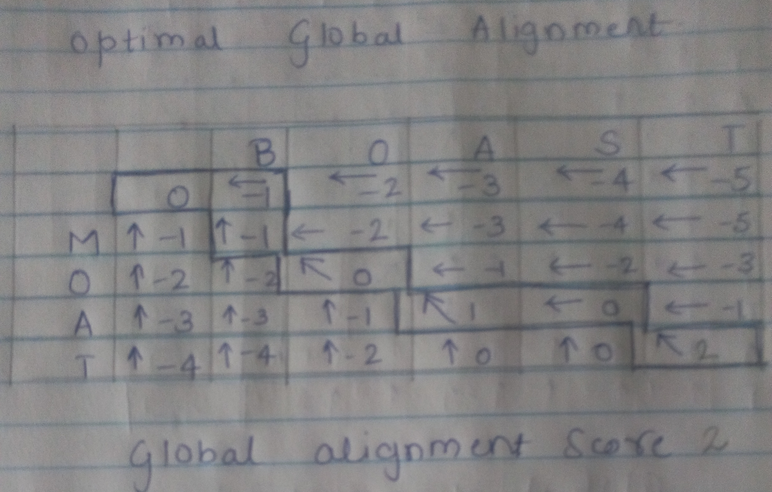

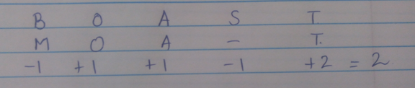

Global Alignment is 2

Problem 4-2. (20 points) Jones & Pevzner, Problem 6.20, page 214.

Consider the sequence v = TACGGGTAT and w = GGACGTACG.Assume that the match premium is +1 and that the mismatch and indel penalties are -1.

1. (8 points) Fill out the dynamic programming table for a global alignment between v and w.

a) Draw arrows in the cells to store the backtrack information.

b) What is the score of the optimal global alignment & what alignment does this score correspond to?

2. (8 points) Fill out the dynamic programming table for a local alignment between v and w.

a) Draw arrows in the cells to store the backtrack information.

b) What is the score of the optimal local alignment and what alignment does this score correspond to?

3. (4 points) Suppose we use a gap penalty where it costs -20 to open a gap, and -1 to extend it. Scores of matches and mismatches are unchanged. What is the optimal global alignment in this case and what score does it achieve? (Hint: You do not need to refill in a dynamic programming table to solve this!)

Solution:

(1)

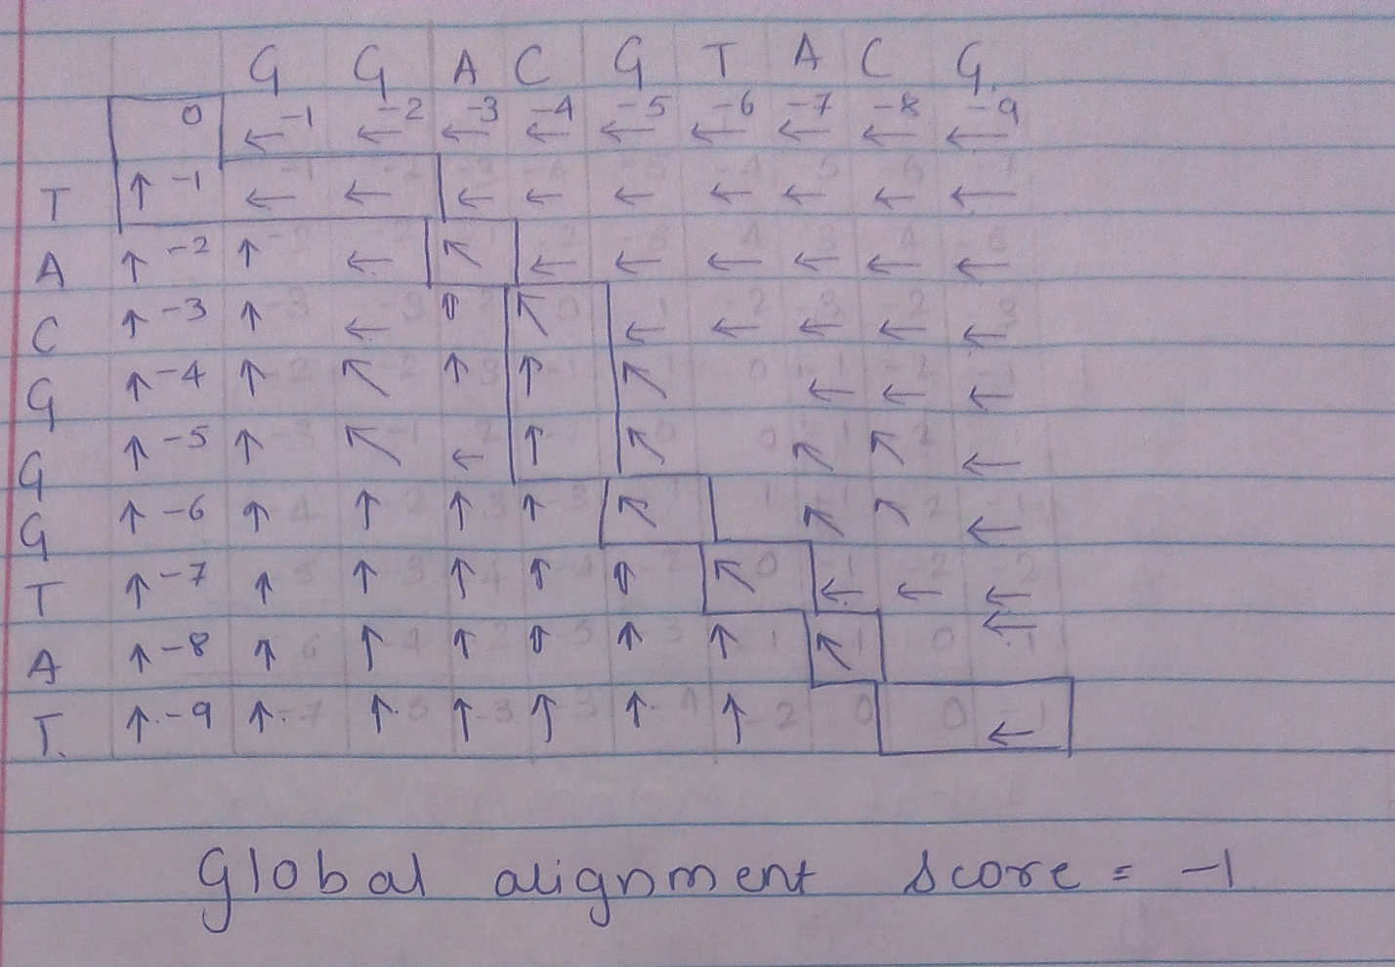

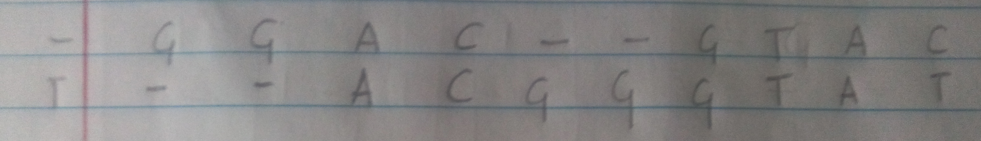

(2)

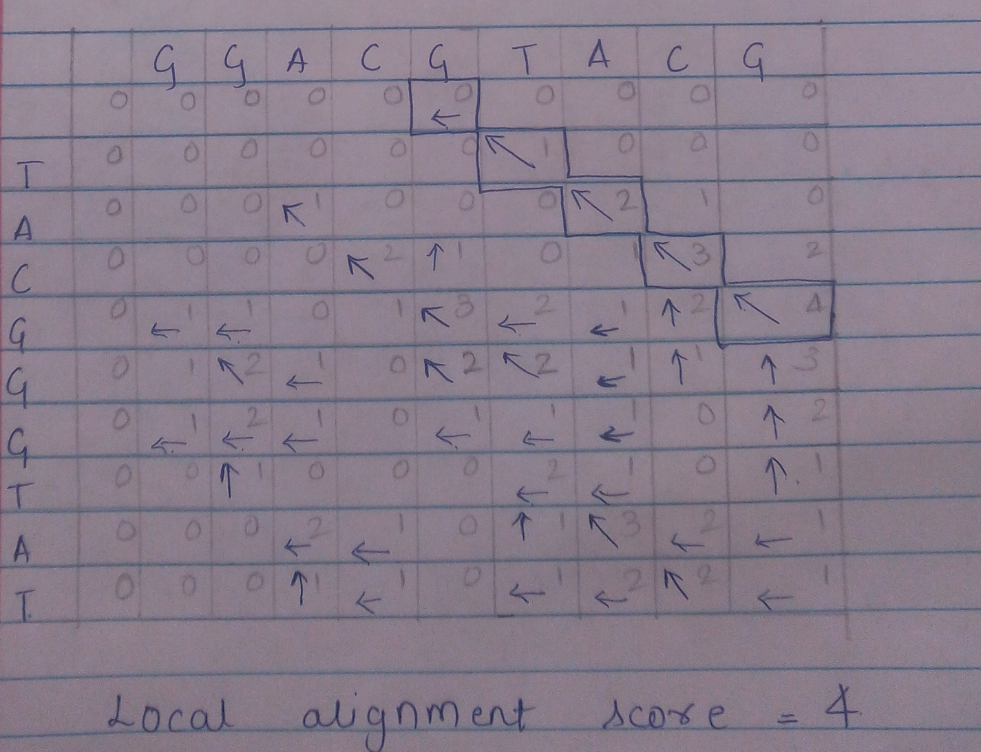

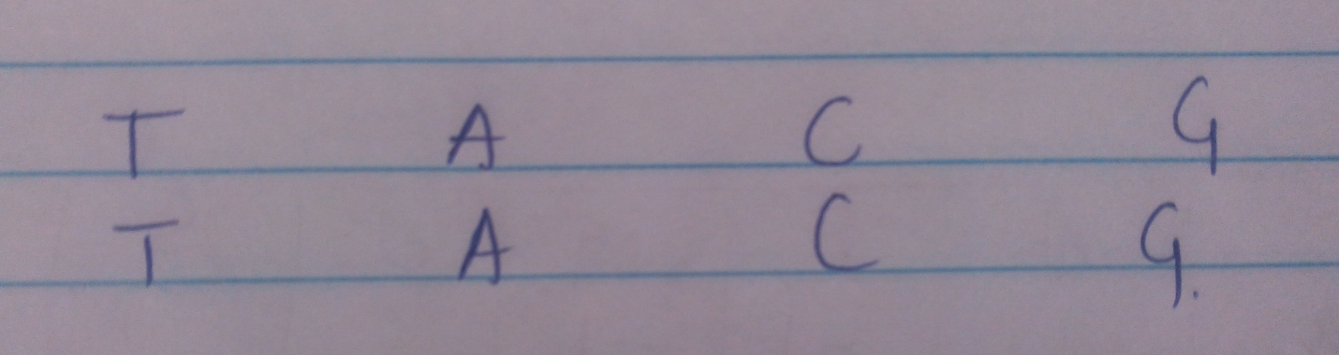

(3) Now Suppose we use a gap penalty where it costs -20 to open a gap, and -1 to extend it. Scores of matches and mismatches are unchanged then we get gap penalty for global alignment

-20-21-21-20=-82

We can adjust the alignment to get the optimal score.

Below is an adjust alignment.

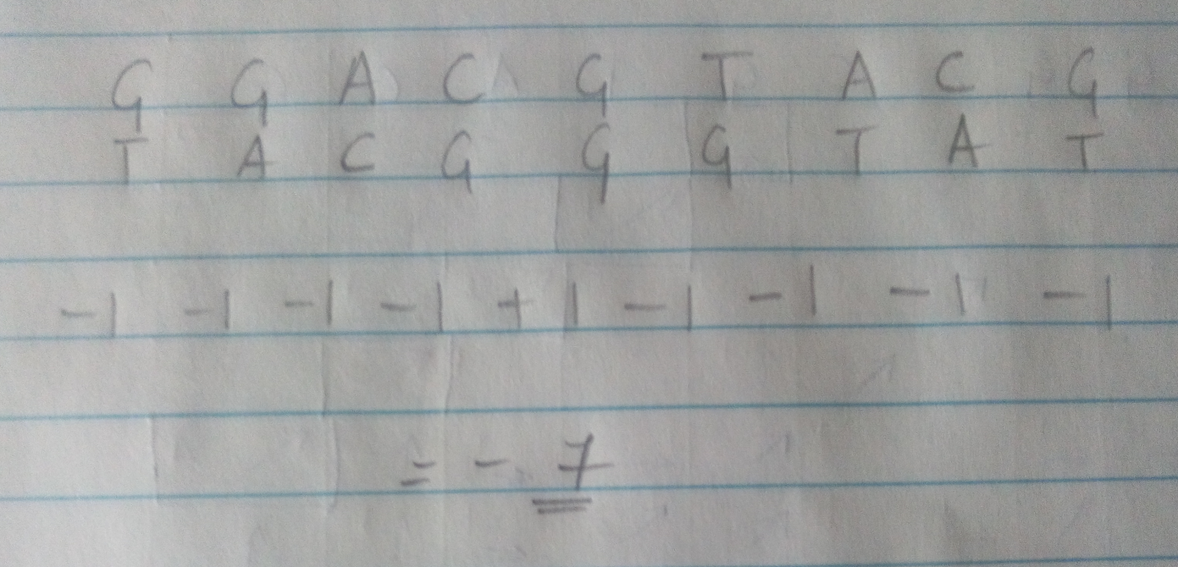

The optimal score can be -7.

Problem 4-3. (20 points)



1. (10 points) Given sequences v and w, write an efficient algorithm (in Matlab or Java or something else

that is easy to read!) that will determine if v could be an infected version of w. Make sure to properly

document and indent your code if you want full credit!

2. (5 points) Submit your source code and screenshots of sample runs showing the correctness of your

algorithm.

3. (5 points) Analyze the time complexity of your algorithm in terms of n: the length of v.

Problem

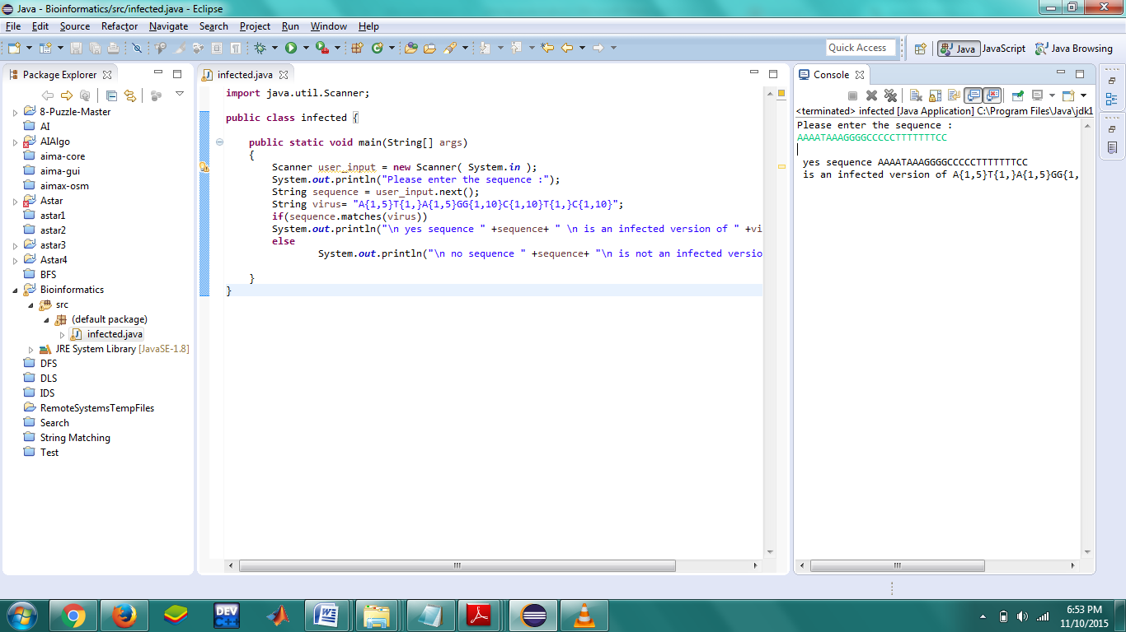

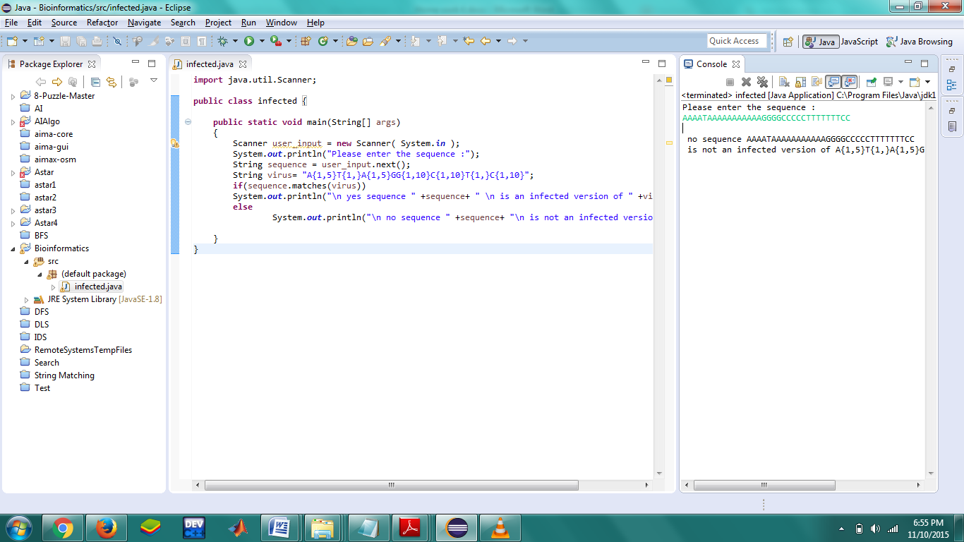

The time complexity will be O(n).

Problem 4-4. (40 points)

Write a program (in Matlab or Java or something else that is easy to read!) that solves the Local Sequence Alignment problem using the dynamic programming strategy. Make sure to properly document and indent your code if you want full credit! (30 points)

The input includes strings v, w and a scoring matrix δ.

The output is an alignment of v and w whose score (as defined by the matrix δ) is maximal among all possible alignments of v and w.

1. Run your program to find the optimal local alignment for 1213434222 and 1343422421 under the match premium +1, mismatch penalty -1, and indel penalty -0.5.

2. (10 points) Submit your source code and screenshots of a sample run showing the correct output of your algorithm when given v = 1213434222 and w = 1343422421

Solution:

public class LocalSequenceAlignmentProblem {

public static void main(String[] args)

{

String seq1 = "1213434222";

String seq2 = "1343422421";

double temp2 = 0.0;

int maxi = 0;

int maxj = 0;

double Max=0;

int i,j;

double arr[][] = new double[seq2.length()+1][seq1.length()+1];

for(i = 1;i <= seq2.length(); i++)

for(j = 1; j <= seq1.length() ; j++)

{

double temp = arr[i-1][j] - 0.5;

double max = 0.0;

if(seq2.charAt(i-1) == seq1.charAt(j-1))

max = arr[i-1][j-1] + 1;

else

max = arr[i-1][j-1] - 1;

if(temp > max)

max = temp;

temp = arr[i][j-1] - 0.5;

if(temp > max)

max = temp;

if(max < 0)

max = 0;

arr[i][j] = max;

if(temp2 < max)

{ temp2 = max;

maxi = i;

maxj = j;

}

}

System.out.print(" ");

for( i = 0;i<seq1.length();i++)

{

System.out.print(seq1.charAt(i)+" ");

}

System.out.println(" ");

System.out.print(" ");

for( i = 0;i <= seq2.length(); i++)

{

for( j = 0; j <= seq1.length() ; j++)

System.out.print(arr[i][j]+" ");

System.out.println();

if(i < seq2.length())

{

System.out.print(seq2.charAt(i)+ " ");

}

}

Max=temp2;

int nexti = 0;

Character[][] path = new Character[maxi+1][2];

int count = 0;

for( i = maxi ; i >= 1 ; )

{

for( j = maxj ; j >= 1 ; )

{

if(seq2.charAt(i-1) == seq1.charAt(j-1) && arr[i-1][j-1]+1 == temp2)

{

temp2 = arr[i-1][j-1];

path[count][0] = seq2.charAt(i-1);

path[count++][1] = seq1.charAt(j-1);

nexti = i-1;

i=i-1;

maxj=j-1;

}

else if(arr[i-1][j-1]-1 == temp2)

{

temp2 = arr[i-1][j-1];

path[count][0] = seq2.charAt(i-1);

path[count++][1] = seq1.charAt(j-1);

nexti = i-1;

i=i-1;

maxj=j-1;

}

else if(arr[i-1][j] - 0.5 == temp2)

{

temp2 = arr[i-1][j];

path[count][0] = seq2.charAt(i-1);

path[count++][1] = seq1.charAt(j-2);

nexti = i-1;

i=i-1;

maxj=j;

}

else if(arr[i][j-1] - 0.5 == temp2)

{

temp2 = arr[i][j-1];

path[count][0] = seq2.charAt(i-2);

path[count++][1] = seq1.charAt(j-1);

nexti = i-2;

maxj=j-1;

}

break;

}

}

System.out.println();

for( i = 0;i<count;i++)

{

if(i != 0 && path[i-1][0] == path[i][0])

System.out.print("(- "+path[i][1]+ ")");

else

System.out.print("(" +path[i][0]+" "+path[i][1]+ ")");

System.out.print("-->");

}

System.out.println();

System.out.println("The score for local alignment is "+Max);

}

}

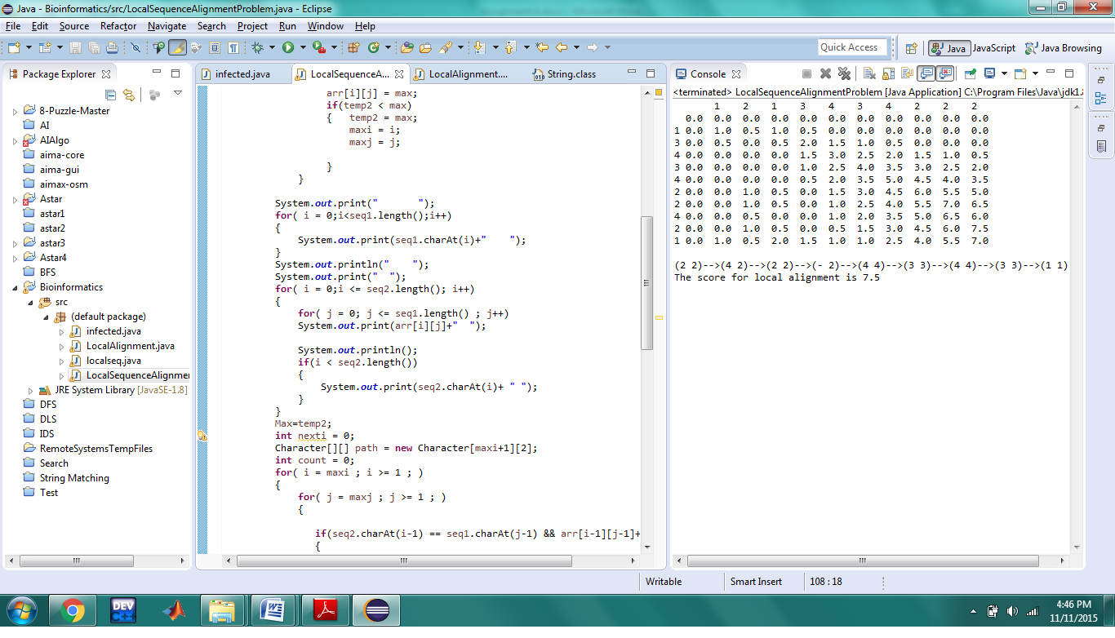

Refrences:

[1] Neil C. Jones And Pavel A. Pevzner "An Introduction To Bioinformatics Algorithm ".

[2]https://en.wikipedia.org/wiki/Sequence_alignment#Global_and_local_alignments

[3]https://en.wikipedia.org/wiki/Needleman%E2%80%93Wunsch_algorithm#Advanced_presentation_of_algorithm